**Exercise No: 2 Date:**

**1. Write a C++ program to find maximum from an array of integers**

#include<iostream>

using namespace std;

int main()

{

    int arr[5];

    cout<<"Enter elements in array: "<<endl;

    for(int i=0; i<5; i++){

        cin>>arr[i];

    }

    int max= arr[0],pos=0;

    for(int i=1; i<5; i++){

        if(arr[i]>max){

            max=arr[i];

            pos=i;

        }

    }

    cout<<"Maximum number in the array is: "<<max<<" at position "<<pos+1<<endl;

}

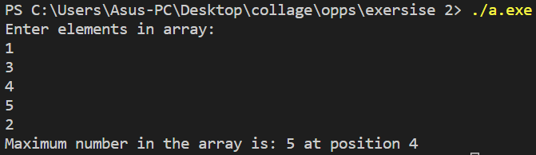

**2. Writ a C++ program to check if a number is a palindrome number or no**

#include<iostream>

using namespace std;

int main()

{

    int num, rev=0;

    cout<<"Enter a number: "; cin>>num;

    int copy = num;

    while(copy>0)

    {

        rev = rev * 10 + copy % 10;

        copy /= 10;

    }

    if(rev==num) cout<<num<<" is a palindrome"<<endl;

    else cout<<num<<" is not a palindrome"<<endl;

    return 0;

}

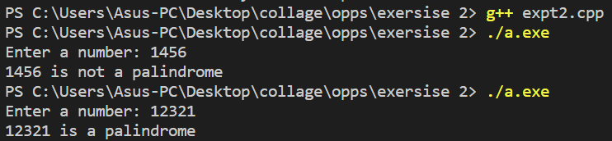

**3. Write a C++ program to print a Fibonacci triangle**

1

1 1

1 1 2

1 1 2 3

1 1 2 3 5 and so on

#include<iostream>

using namespace std;

void fib(int n)

{

    int a=0,b=1,temp;

    cout<<a<<" ";

    for(int i=1; i<n; i++){

        cout<<b<<" ";

        temp = b;

        b += a;

        a = temp;

    }

}

int main()

{

    int n,a=0,b=1;

    cout<<"Enter the number of terms for fibonaci series: "; cin>>n;

    for(int i=1; i<=n; i++){

        fib(i);

        cout<<endl;

    }

}

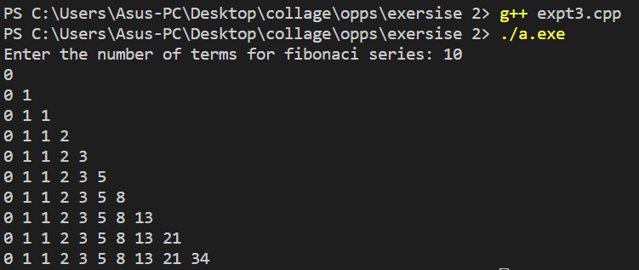

**4. Write a C++ program to find first and last digit of any number**

#include<iostream>

using namespace std;

int main()

{

    int num, first, last, temp;

    cout<<"Enter a number: "; cin>>num;

    temp = num;

    last = num % 10;

    while(temp>0){

        first = temp % 10;

        temp /= 10;

    }

    cout<<"\nNumber: "<<num<<"\nFirst digit : "<<first<<"\nlast digit : "<<last<<endl;

}

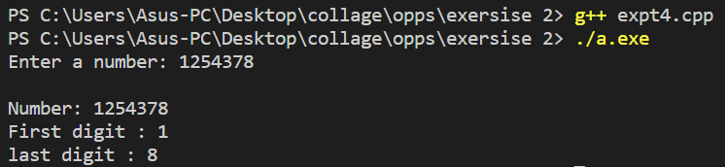

**5. Write C++ Program to interchange diagonals of a matrix**

#include<iostream>

using namespace std;

int main()

{

    int n, tmp;

    cout<<"Enter size of rows of a squre matrix: "; cin>>n;

    int **array = new int* [n];

    for(int i = 0; i < n; i++)

        array[i] = new int [n];

    cout<<"Enter Elements of array"<<endl;

    for(int i = 0; i < n; i++){

        for(int j = 0; j < n; j++){

            cin>>array[i][j];

        }

    }

    cout<<"Mtrix:"<<endl;

     for(int i = 0; i < n; i++){

        for(int j = 0; j < n; j++){

            cout<<array[i][j]<<" ";

        }

        cout<<endl;

    }

    for(int i = 0, j = n-1 ; i < n && j >= 0; i++, j--){

            tmp = array[i][i];

            array[i][i] = array[i][j];

            array[i][j] = tmp;

    }

    cout<<"After Interchanging of diagonals "<<endl;

     for(int i = 0; i < n; i++){

        for(int j = 0; j < n; j++){

            cout<<array[i][j]<<" ";

        }

        cout<<endl;

    }

    return 0;

}

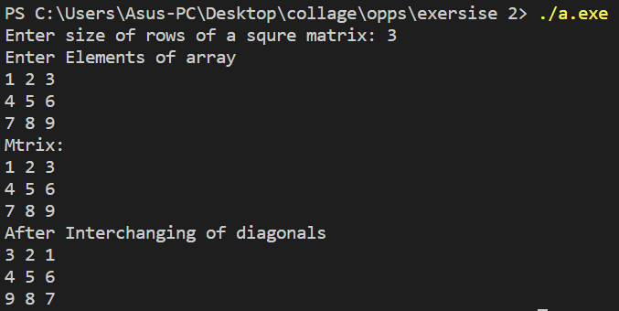

**Nitesh Naik**

**(Subject Faculty)**